Name:_________________________
Advisory:________________________
Date: Monday, October 28, 2019
Lesson 9 Quiz Answers
1
2 | Bubble on KB Bubble sheet
3 | Bubble on KB Bubble sheet
4 | Bubble on KB Bubble sheet
5 | Bubble on KB Bubble sheet
6
7
7.RP.1-Unit Rate | 7 | _________/7 | Mastery Score  6/7 | Mastered?

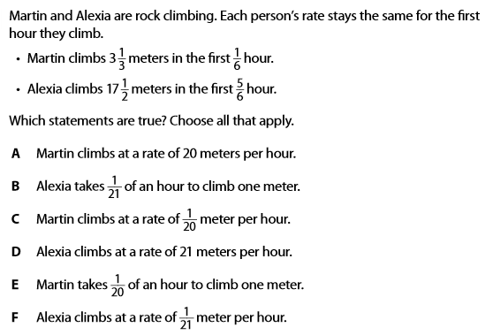
Lesson 9 Quiz

(Hint: find unit rate for $\frac{meters}{hours}$ and $\frac{hours}{meters}$ to determine which statements are true)

- $5\frac{3}{4}$
- $\frac{23}{12}$
- $23$
- $17\frac{1}{4}$
(Hint: Make sure you are looking for the correct Unit rate)

For 3-5 Use the following:
Mark A for True and B for False
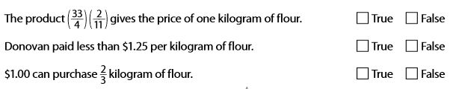
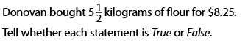

(Hint: Make both measurements into fractions to determine if 3 is correct, solve for unit rate for 4 and 5)

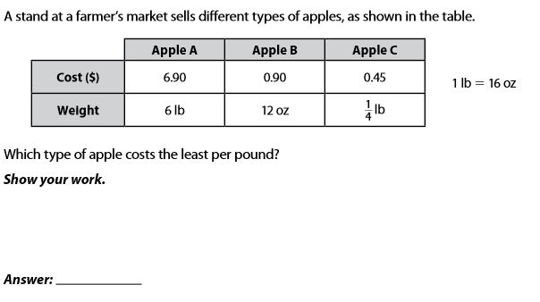

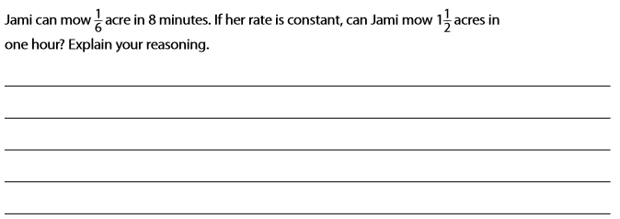
(Hint: convert to pounds then solve each unit rate then compare)

(Hint: convert minutes to hours, solve then compare)

