Name:_____________________________
Advisory:__________________________
Date: _________________
Unit 1: Rational Numbers
Summative Assessment Retake
Skill | Questions |  | Score Needed for Mastery | Score | Mastery
7.NS.1a  Zero Sums and Opposites | Calculator Inactive:  MC: 14 | Calculator Active: | 1 / 1 | ___ / 1 =  ______%
7.NS.1b  Adding Rational Numbers(conceptual) | Calculator Inactive:  MS:10 | Calculator Active:  MC:28,30(2pts) | 4 / 4 | ___ / 4 =  ______%
7.NS.1C  Subtracting Rational Numbers(conceptual) | Calculator Inactive: | Calculator Active:  OR: 31(2pts) | 2/ 2 | ___ / 2 =  _______%
7.NS.1d  Add and Subtract Rational Numbers | Calculator Inactive:  MC: 6,7,8,9 | Calculator Active:  OR:29(2pts) | 5/ 6 | ___ / 6 =  _______%
7.NS.2a  Multiply Rational Numbers | Calculator Inactive:  MC:11,12 | Calculator Active:  OR: 32(2pts) | 4/ 4 | ___ / 4 =  _______%
7.NS.2b  Dividing Rational Number | Calculator Inactive:  MC: 4 | Calculator Active:  OR:21 | 2 / 2 | ___ / 2 =  _______%
7.NS.2c  Multiply and Divide Rational Numbers | Calculator Inactive:  MC:3 | Calculator Active:  OR:18,19,20,22 | 4 / 5 | ___ / 5 =  _______%
7.NS.2d  Convert rational number to decimals | Calculator Inactive:  MC:1,5 | Calculator Active:  OR: 23,24,25,26 | 5 / 6 | ___ / 6 =  _______%
CC 7.NS.3  Solve real-world problems | Calculator Inactive:  OR:2, 13,15,16,17 | Calculator Active: | 4 / 5 | ___ /5 =  _______%
Unit 1 Mastery: ____________%
Overall Mastery: _______________%
Parent Signature: __________________________________________________

Part 1: Calculator Inactive
For 1-2 Use the following:
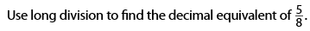

- 1.6
- 1.$\overline{6}$
- 0.625
- 0.$\overline{6}$
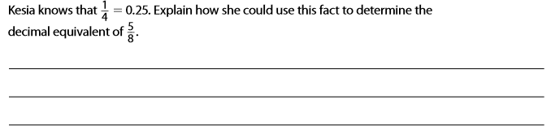

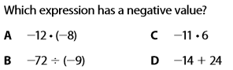

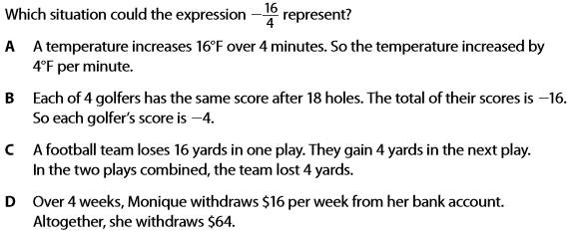

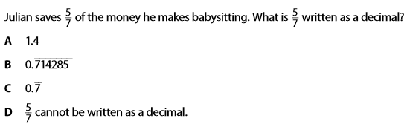

For 6-9 mark A for true, B for False
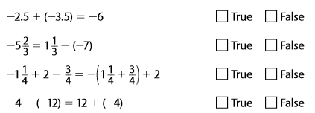

For 11-13 Use the following:
- What is an appropriate estimate for the amount of change for a week (7 days)?
  - -5
  - -10$\frac{1}{2}$
  - -7 $\frac{1}{2}$
  - – 15
- Use exact values, what is the amount of total change in water evaporated?
  - –8 $\frac{1}{8}$
  - -7 $\frac{5}{8}$
  - -11 $\frac{3}{8}$
  - -15 $\frac{1}{8}$
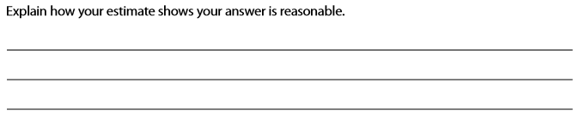

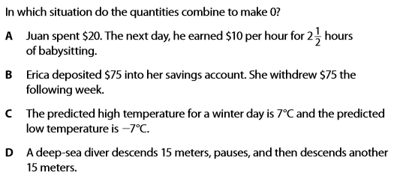

For numbers 15-17 use the following:

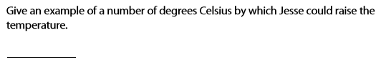

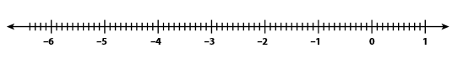

Part 2-Calculator Active

18- 22 Fill in the blanks to complete each statement and make it true
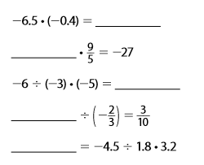

23- 26 use the following. Mark a for True and B for False:
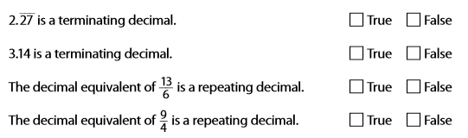

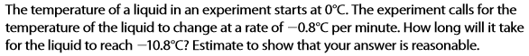

- 8.64
- -8.64
- 13.5
- -13.5

  - 9.25
  - -9.25
  - 2.75
  - 3.75

29-31 complete the following:
